Zoom Car Booking Class Diagram

Zoom Car Booking Sequence Diagram

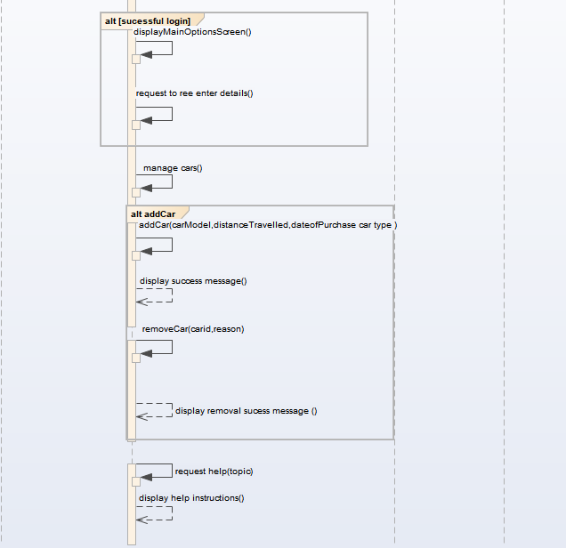

Digital Home System Class Diagram

Digital Home System Sequence Diagram

Library Management System Class Diagram

Library Management System Sequence Diagram

Monitoring Operating System Class Diagram

Monitoring Operating System Sequence Diagram

CCTNS Class Diagram

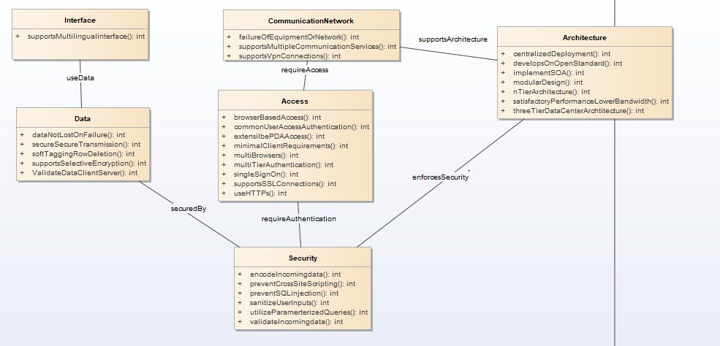

CCTNS Sequence Diagram

College Registration System Class Diagram

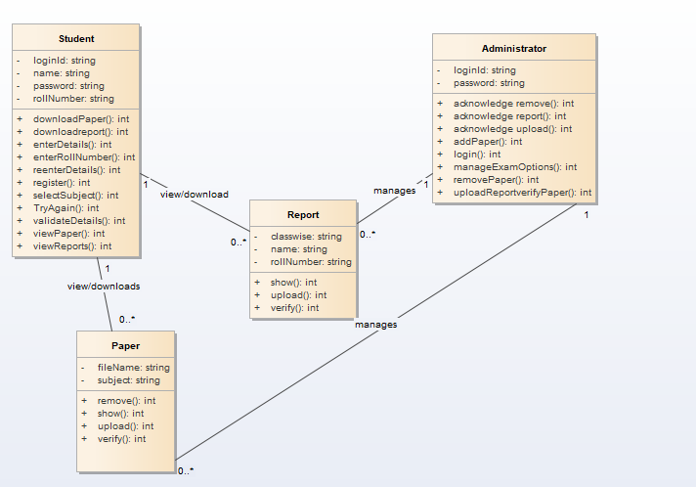

College Registration System Sequence Diagram

EStore Class Diagram

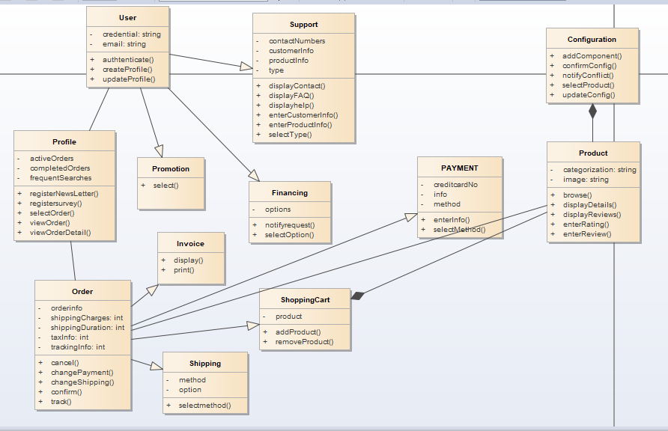

EStore Sequence Diagram

iCoot System Class Diagram

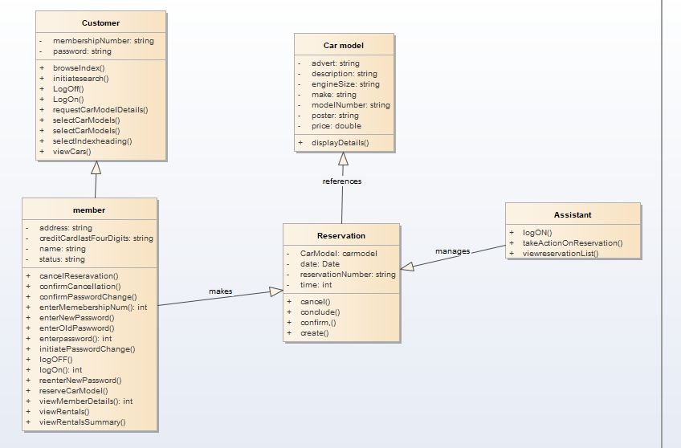

iCoot System Sequence Diagram

LIS Class Diagram

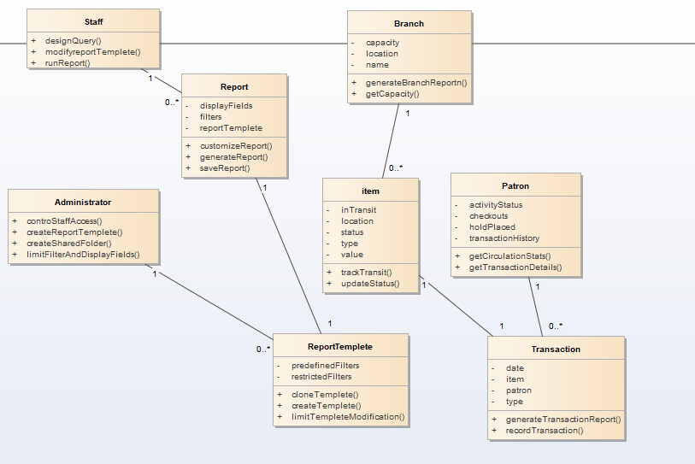

LIS Sequence Diagram

Online Bus Reservation Class Diagram

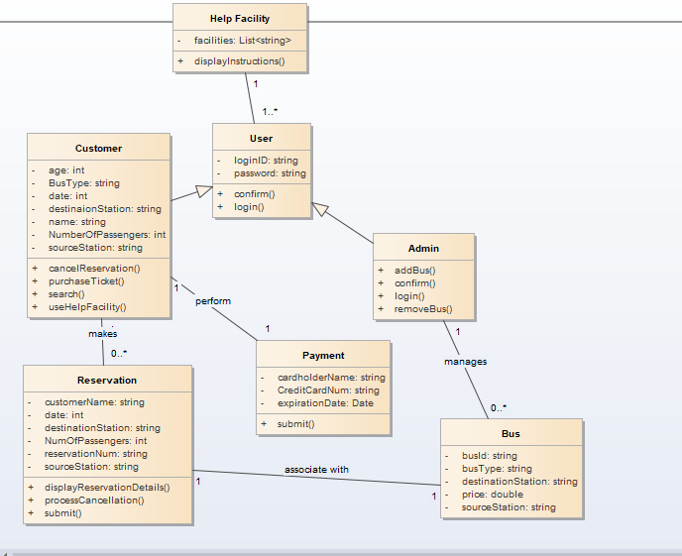

Online Bus Reservation Sequence Diagram

Online Book Store Class Diagram

Online Book Store Sequence Diagram

Online Pet Store Class Diagram

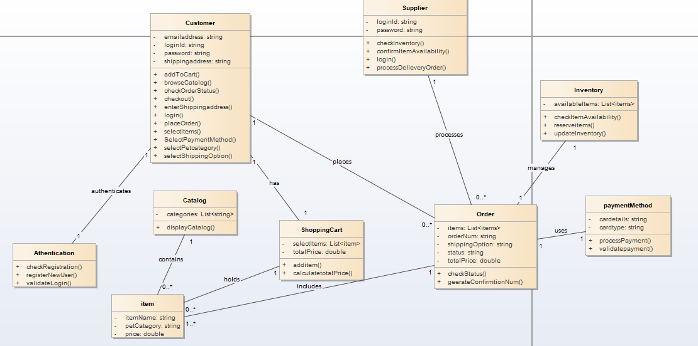

Online Pet Store Sequence Diagram

Puget Class Diagram

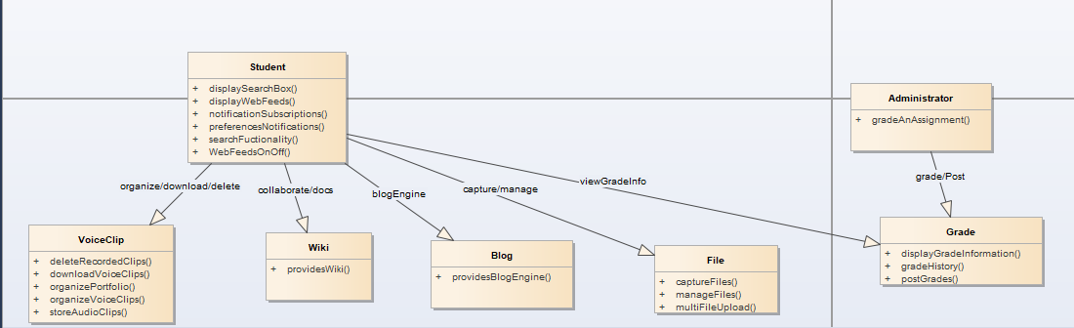

Puget Sequence Diagram

Railway Reservation Class Diagram

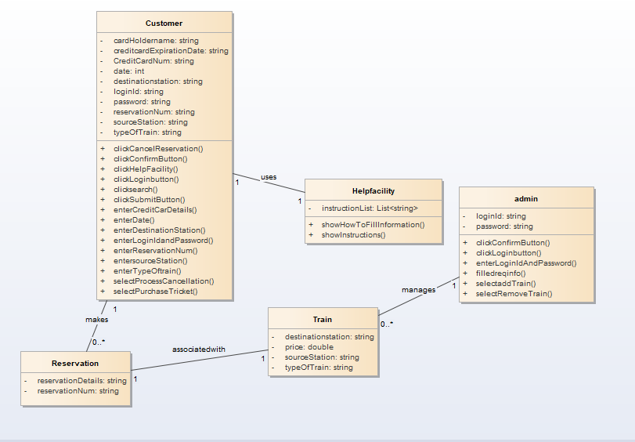

Railway Reservation Sequence Diagram

Online Discussion Group Class Diagram

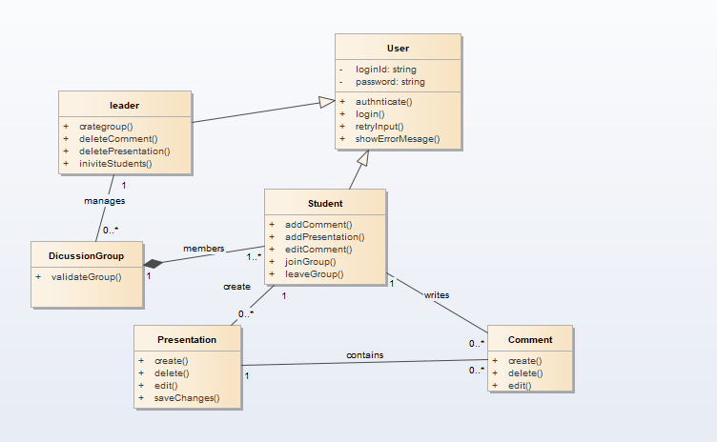

Online Discussion Group Sequence Diagram

